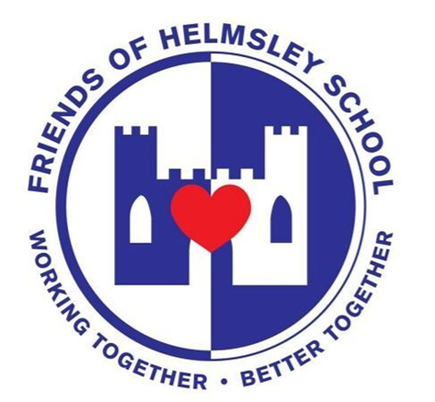
Friends of Helmsley School Newsletter

The Friends of Helmsley School raise money and organise events and experiences for the pupils of Helmsley School. Our aim is to further enhance the education, wellbeing and experiences of our children, families and wider community. We do this by organising and hosting a number of events and social activities throughout the year. We arrange the Summer Fair, Beetle Drive and Halloween Disco and in the past we have paid for the whole school to attend the pantomime in York, organised Mother’s Day and Father’s Day events, paid for the Yr 6 leavers hoodies and additional resources for the school.
The friends of Helmsley School is open to everyone. We welcome new helpers or anyone who would like to give an input into events or how we spend fundraising. You can join our WhatsApp group where you can make or respond to suggestions or attend a meeting.
Events
We are excited to be organising in person events again, and the Valentines Disco we held was a wonderful event for the children. Thank you to all the teachers who helped, the caretaker for the clean up afterwards and our wonderful Mrs Feather for organising and selling the tickets. We raised a total of £371.82 and after paying for the disco and other costs we have a profit of £179.28 which will go towards future events or resources for the school.
Chocolate Bingo - this event exceeded our expectations, and 108 tickets were sold. It was a wonderful turnout and we raised £487. Thank you to Mrs Dunn for her excellent bingo calling and to all the Teachers who gave up their time to help with the event. Thank you also to the parents for their generous chocolate donations.
The Royal Blue Ball will be held on the 8th of July. This will be our biggest event to date! It is a black-tie evening ball for grown-ups at the Feathers Hotel in Helmsley. Tickets are available from the Helmsley School Office or contact Jo on 07968203142.
Summer Fair 24 June 2022- Please save the date!

Chairperson required for the Friends of Helmsley School
We need a chairperson to represent and lead us at events and at meetings. Anyone can apply, they do not need to have previously attended meeting or events. This role does not involve a great deal of work and we have a dedicated and enthusiastic team of volunteers working with the Trustees. If you would like any further information regarding this role then please email us on: FriendsofHelmsleySchool@gmail.com
Second-hand Uniform
Do you have any unwanted or outgrown school uniform items you can donate?
Friends of Helmsley School are setting up a swap shop that will assist Helmsley School parents to manage the cost of uniforms and actively support families.
Further details will be sent out soon.
The minutes from all our meetings and our constitution are on the Helmsley School web page under the ‘about us’ tab.

